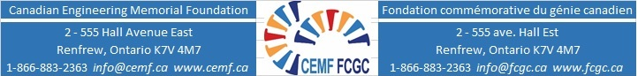

CEMF Undergraduate Awards – Application Form and Check List

Name:
Permanent Mailing Address (Home):
Email:
Telephone:
Alternative Contact Information:
(Indicate whose number/email this is. I.e. Your cell/Parents/etc.)
University: Program:
Program year date as of January 1, 2022:
Year you anticipate graduating from your current program:

Submit each item below including a copy of this list to awards@cemf.ca on or before midnight, January 10, 2022

Application Form and Checklist
Declaration Form
Proof of Citizenship or Permanent Resident status
Informational letter
Summary of your community, extracurricular and sports activities
Your complete presentation with speaking notes
Recording of you speaking about your passion for engineering
Reference A from ________________________ (Name of reference).
Ask this person to send the reference form directly to awards@cemf.ca
Reference B (Name and Contact details only) Name:
Email: Telephone:
Letter of support from ___________________ (Name of person who is writing letter). Ask this person to send the letter directly to awards@cemf.ca

I have read the application materials and agreed to abide by the terms of this award.

Signature: Date:
October 2022

