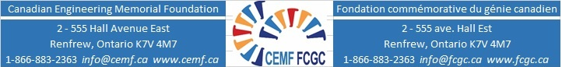

CEMF Graduate Awards – Application Form and Check List
Name:
Permanent Mailing Address (Home):
Email:
Telephone:
Alternative Contact Information:
(Indicate whose number/email this is. I.e. Your cell/Parents/etc.)
University: Program:
Which year of study are you in as of January 1, 2021:
Which year do you anticipate graduating from your current program:

Application Form and Checklist
Declaration Form
Proof of Citizenship or Permanent Resident status
Informational letter
Summary of your community, extracurricular and sports activities
Your complete presentation with speaking notes
Recording of you speaking about your passion for engineering
A five-minute video recording of your demonstration of an engineering principle (from your presentation “Why I Chose Engineering”)
Reference A from ________________________ (Name of referee/reference).
Ask this person to send the reference form directly to awards@cemf.ca
Reference B from _________________________ (Name of faculty supervisor)
Ask this person to send the reference form directly to awards@cemf.ca
Letter of support from ___________________ (Name of person who is writing letter). Ask this person to send the letter directly to awards@cemf.ca .
Submit each item below including a copy of this list to awards@cemf.ca on or before midnight ET, January 10, 2021

I have read the application materials and agreed to abide by the terms of this award.
Signature: Date:

