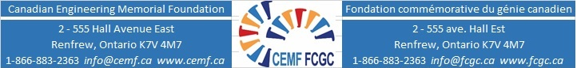

Applicant Information on Community, Extracurricular and Sports Activities
Name: Email:

University: Program:

Year | Community Activity | Timing | Award/Recognition
2018 | Community theatre group | Two plays. Practice two nights/ week | Regional
 | Extracurricular, including sports
2017 | Soccer – High School | Weekly practice and games during school year | Made Team Captain
 | Other
October 2020

