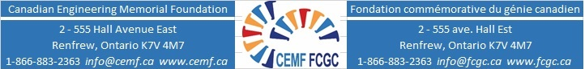
ENGINEERING AMBASSADOR AWARD REFERENCE FORM

Applicant’s Name:

Name of the Reference: Title:
Organization or Institution: Telephone Number:
Full Mailing Address:

Completion of this recommendation form is a necessary part of the application process for any CEMF Scholarship.
Referees are asked to send completed reference form directly to awards@cemf.ca. Applicant should ensure that referees are aware of the application deadline.

How long have you known the Applicant and in what capacity?

What, in your opinion, differentiates this Applicant from her peers?

Comment on Applicant's leadership potential, organizational and motivation skills.

Comment on the Applicant's communication and interpersonal skills, and ability to work with others.

Comment on the Applicant's analytical skills, creativity, curiosity, perseverance, problem-solving and “doing.”

When you compare this Applicant to other students at her level you have taught, led, guided, employed, how does she compare overall?

Exceptional | Above Average | Average | Unable to Rank

Feel free to provide any further comments that you feel would aid the Judging Committee in the evaluation of the Applicant. Additional pages may be attached.

Signature of Reference: Date:

________________________ ____________________________

October 2020

