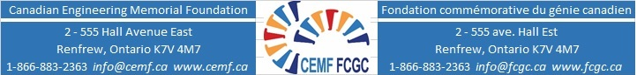

Applicant Information on Community, Extracurricular and Sports Activities
(Examples indicated in red – add more rows as required)
Name: _____________________________________ Email: ________________________

University: ____________________ Program: ___________________________

Year | Community Activity | Timing | Award/Recognition
2018 | Community theatre group | Two plays. Practice two nights/ week | Regional
 | Extracurricular (including sports)
2017 | Soccer – High School/ | Weekly practice and games during school year | Made Team Captain
 | Other
October 2020

